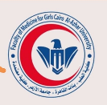
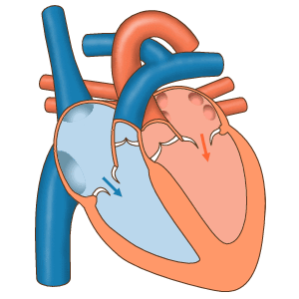
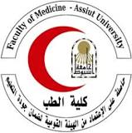
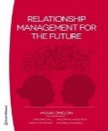
Version 4
An outcome of Work packages 4 & 5 Study, In Service Training & Capacity Building
Basic Course Information
Course Title |  | BM5 & 6 : Primary Care & Family Medicine Approach to  CARDIOVASCULAR DISEASES (CVDs) IN PRIMARY CARE (PC)
Credit hours | : | Level A +B 45 Hrs (Contact/teaching Hours-Approx.10 ECTS)
Program Dean and Grant holder Coordinator | : | Prof Mosad Zineldin, Linnaeus University  Dep. of Medicine and Optometry -Sweden
Course Instructors | : | Professors from school of medicine Italy, Egypt and Lebanon
Course Aim & Description
It is our pleasure to offer the 5th &6th study , training and capacity building training courses as part of our EU/Erasmus+ project. The wider objective is to shed a higher light on how to improve the CVDs diagnoses, and treatments through PC&FM implementations.

Emphasis will be placed on developing a structured system of primary care which supports patients in managing their condition and maintaining a healthy lifestyle.

This module will use current guidelines and evidence based practice in cardiovascular care as a basis for theoretical and practical lessons. It will cover the main subdivisions of CVD problems by providing deeper knowledge about how they should be diagnosed and managed in the primary care (PC) settings.

The course period is 8-10 weeks by 2-4 afternoon hours per week. Its mandatory to attend at least 70% of the lectures and pass the Quiz &/or course assignments to get an attendance/achievement Certificate.

The specific Learning objectives/Outcomes:
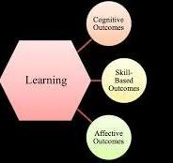
1- Describe the most common CVD conditions
2- Manage the most common CVD conditions
3- Use risk scoring programmes to define CVD risk
4- Devise and implement appropriate management plans for patients with CVD including risk factor management and appropriate pharmacotherapy
5- Explain the use of ambulatory and home based BP monitoring in management of hypertension
6- Outline a systematic approach to the diagnosis and follow up of heart failure
7- Differentiate angina from other causes of chest pain
8- Diagnose and treat new cases of atrial fibrillation
9- Plan the follow up of patients who have had surgery for heart disease
10- Interpret an ECG
Main contents. There are also some subcontents
- Cardiovascular Risk Assessment, Lifestyle and Behaviour Change
- Management of Hypertension & Hyperlipidaemia
- Diagnosis and Management of Cardiac Arrhythmias and Stroke Prevention
- Diagnosis and Management of Chronic Heart Failure, Ischaemic Heart and Valvular Heart Disease
- Presentation, Diagnosis and Management Syncope. Sudden Cardiac Death
- Cardiovascular Disease and Womens Health
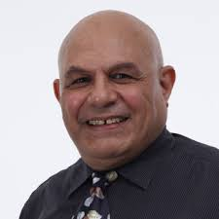
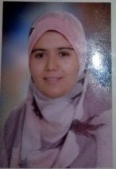
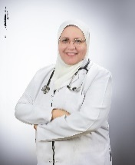
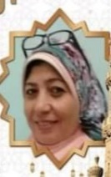
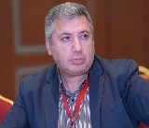
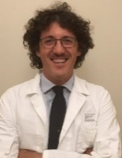
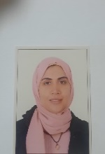
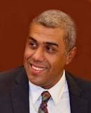
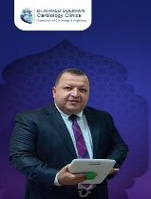
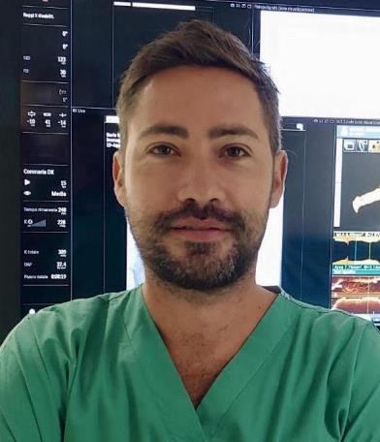Prof. Mosad Zineldin
Version 3
Date | Time/SWEDISH | Topic | Lecturer/Trainer
Thursday  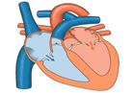  30/5/24  30/5 3-7 pm | 300-4.00  Swedish time | Welcome  Course overview  Participant Presentations | Dr. Mosad Zineldin: Prof.  Dep. Of Medicine & optometry  Linnaeus University-Sweden
 | 4.00 -7.00 pm | Lecture 1  Cardiovascular Risk Assessment, Lifestyle Modification and Behaviour Change | Dr. Eman Rashed Professor of Cardiology- Faculty of Medicine for girls-Azhar University
 | https://lnu-se.zoom.us/j/63940412176?pwd=RWJuREpoQmlTSHB5NHg0dFFEWmlSdz09
Saturday 8/6/24    3/6 3 -7 pm | 4.00- 7.00 | Lecture 2  Guidelines- Driven Management of Hypertension | Prof. Dr. Hossam Hassan  Prof. of Interventional Cardiology  Assiut University -Faculty of Medicine
 | https://lnu-se.zoom.us/j/64425366034?pwd=dVZ3ZG9qbVFVRGRBS0h5MTZhUlFIUT09
Friday  14/6/24 | 5.00 -8.00 | Infections of the heart; Laboratory perspectives | Dr. Marwa A.A El-said Abdelghany  Faculty of Medicine for Girls, Azhar University-
Friday  14/6/24 | https://lnu-se.zoom.us/j/63989365917?pwd=eHpOWHl6eUx2VkorWFk2NndzNHprUT09  Mötes-ID: 639 8936 5917 PasswordCode-: 634232
Tuesday  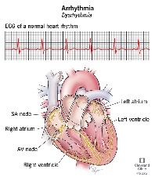  25/6/24  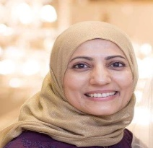  Genoa  Italy & via ZOOM | 8.30 -9.00 Regist  09.00-10.45 | Lecture 4  Acute Heart Failure and Cardiogenic Shock | Prof. Italo Porto  Dep.of Internal Medicine and Specialties  School of Medicine- Genoa University
 | 10.45- 12.30 | Lecture 5  Presentation, Diagnosis & Management Syncope. Sudden Cardiac Death | Dr Giuseppe Mascia  Cardiology department  San Martino Hospital, University of Genoa
 | 12.30- 13.00 | Launch Break
 | 13.00- 14.30 | Lecture 6  Diagnosis and Management of Cardiac Arrhythmias and Stroke Prevention. | Prof. Dr. Abeer Shawky  Professor of CVD  Azhar University-Faculty of Medicine for Girls.
 | 14.30 -17.00 | Filed tour/visit to the CVD Departments s | Cardilogy professors  School of Medicien  Genoa University
Wednesday  26/6/24  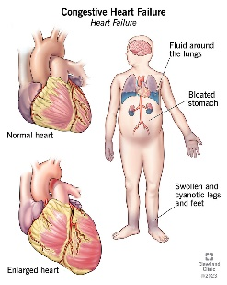  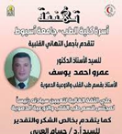  Genoa-Italy | 9.00-10.45 | Lecture 7  Diagnosis and Management of Chronic Heart Failure | Dr Matteo Toma  Cardiovascular Disease Unit  San Martino Hospital  University of Genoa
 | 10.45-12.30 | Lecture 6  Diagnosis and Management of Acute Coronary Syndromes guided by Intravascular Imaging” | Dr Rocco Vergallo  Interventional Cardiologist, UOC
 | 12.30- 13.00 | Launch Break
 | 13.00-14.30 | Lecture 7  Congestive Heart Failure: Types, Symptoms and Causes | Prof. Dr. Amr Ahmed A. Youssef  Prof. of Cardiology  Faculty of Medicine- Assiut Un
 | 14.30 -17.00 | Filed tour/visit to the CVD Departments s | Cardiology prof. School of Medicine  Genoa University
Thursday  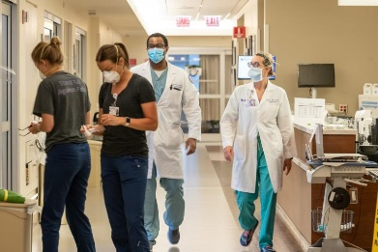  27/6/24 | 09.00 – 13.00 | Clinical tours and tasks  Groups 1-2  At the dep of VCDs | Dr. Pierfilippo Vianello  Prof. Pietro Ameri  Prof. Marco Canepa.  Faculty of Medicine., University of Genoa
 | 13.00 -17.30 | Clinical tours and tasks  Groups 3-4  At the dep of VCDs | Dr. Pierfilippo Vianello  Prof. Pietro Ameri  Prof. Marco Canepa.  Faculty of Medicine, Genoa Univ .
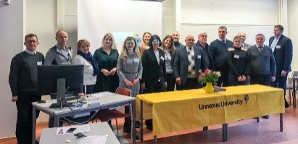  Friday 28/6 | 09.30.14.00 | Reflection-round table discussion, conclusion, and recommendations | UNIGE and Dr. Mosad Zineldin:
3/7/24  14.00- 17.00 | Diagnosis and Management of Ischaemic Heart Disease and Valvular Heart Disease | Dr. Haidy Mohamed  Faculty of medicine for girls- Azhar University
8/7/24  14.00- 17.00 | Medical Nutrition therapy for CVD patients | Dr. Jessy El Hayek, & Dr. Najwa El Gerges  Faculty of Nursing & Health Sciences  Notre Dame University-LB
12/7/24  14.00 -17.00 | Presentation, Diagnosis and Management Syncope. Sudden Cardiac Death | Dr. Rehab Hamdy  Faculty of medicine for girls- Azhar University
15/7/24  15.00 -18.00 | Cardiovascular Disease and Womens Health | Dr. Doaa Fouad  Faculty of Medicine, Dep. of Cardiology-  Assiut University
17/7  15.00 -18.00 | Arts in CV history tacking to reach accurate diagnosis | Dr. Eman Rashed  Cardiology- Faculty of Medicine for girls-Azhar University
28/7/2024  18.00 -19.30 | QUIZ To pass the course you need to attend at least 70% of the sessions & 60% correct answers of the quiz | Prof. Dr. Mosad Zineldin:.  Dep. Of Medicine & optometry

1.- Ämne: Zoom meeting invitation - Dr. Mosad Zineldin. Tid: 30 maj 2024 03:00 em Stockholm
https://lnu-se.zoom.us/j/63940412176?pwd=RWJuREpoQmlTSHB5NHg0dFFEWmlSdz09

Meeting ID: 639 4041 2176 Pass/ Code: 803049

2- Tid: 8 juni 2024 03:00 em Amsterdam, Berlin, Rom, Stockholm, Wien
https://lnu-se.zoom.us/j/64425366034?pwd=dVZ3ZG9qbVFVRGRBS0h5MTZhUlFIUT09

Mötes-ID: 644 2536 6034 Lösenkod: 523467

3- Tid: 14 juni 2024 03:00 em Amsterdam, Berlin, Rom, Stockholm, Wien
https://lnu-se.zoom.us/j/63989365917?pwd=eHpOWHl6eUx2VkorWFk2NndzNHprUT09

Mötes-ID: 639 8936 5917 Lösenkod: 634232

